**FAWRY DevOps Internship Report**

**Task 2: DNS Troubleshooting - internal.example.com**

**1**. DNS Resolution Failure

Command: nslookup internal.example.com

Command: nslookup internal.example.com 8.8.8.8

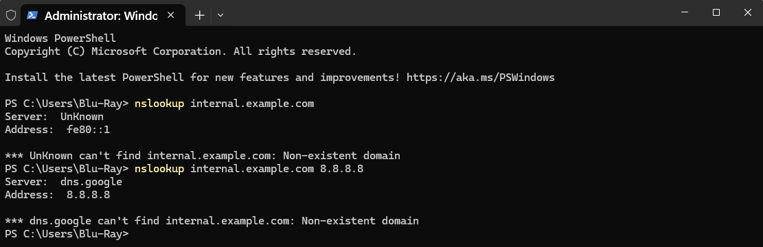

Result: "Non-existent domain" -> Confirms internal domain not in public DNS.

**2-** Manual DNS Bypass via Hosts File to Isolate whether the issue is DNS-related by forcing local resolution and add the it under C:\Windows\System32\drivers\etc\hosts



**3-** verify the entry added to the hosts file by run this command  
ping internal.example.com

This prove internal.example.com resolved to 192.168.1.100

Destination host unreachable (indicates network/server issue)

**4-** Check the port connectivity by run this test command  
Test-NetConnection 192.168.1.100 -Port 80

DNS resolution was successfully bypassed

The true issue is network-level blocking or service unavailability

**Conclusion**

**After adding a manual entry to the hosts file, DNS resolution succeeded (Figure 3), but connectivity to 192.168.1.100 failed (Figures 4-5). This confirms:**

1. ***The original issue was DNS-related***
2. ***Additional network/server troubleshooting is required***

***Next steps would include verifying:***

* **Firewall rules on 192.168.1.100**
* **Web service status on the target server**
* **Network path analysis via traceroute**